ASP.NET Core 8.0 Web API
- (Superset ID - 6363141) Debasish Bisoi

1: First Web API using .NET Core
Code –
Filename – ValuesController.cs
using Microsoft.AspNetCore.Mvc;

namespace MyFirstWebApi.Controllers
{
[Route("api/[controller]")]
[ApiController]
public class ValuesController : ControllerBase
{
[HttpGet]
public IEnumerable<string> Get()
{
return new string[] { "value1", "value2" };
}

[HttpGet("{id}")]
public string Get(int id)
{
return $"value{id}";
}

[HttpPost]
public IActionResult Post([FromBody] string value)
{
return Ok($"Received: {value}");
}

[HttpPut("{id}")]
public IActionResult Put(int id, [FromBody] string value)
{
return Ok($"Updated ID {id} with value: {value}");
}

[HttpDelete("{id}")]
public IActionResult Delete(int id)
{
return Ok($"Deleted item with ID: {id}");
}
}
}

Output –
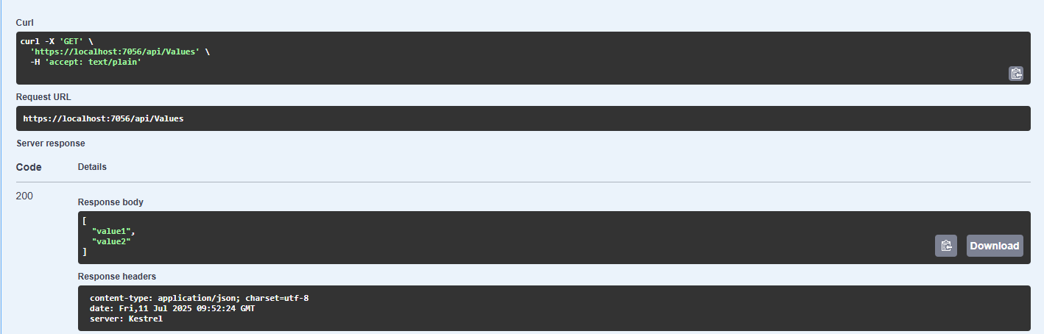
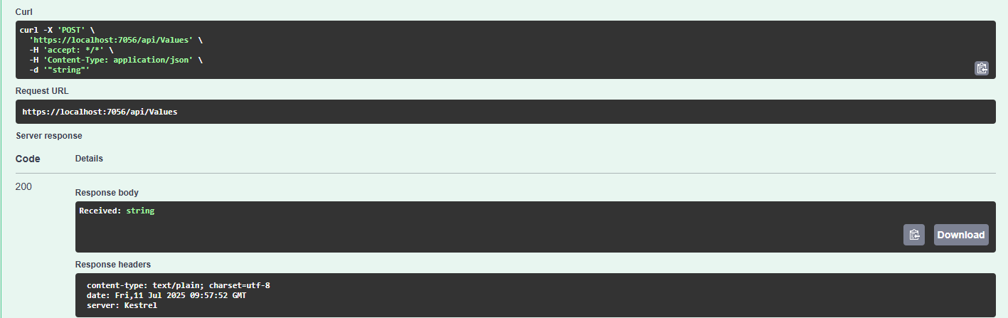

2: Web API using .NET Core with Swagger and Postman
Code –
Filename –Program.cs
using Microsoft.OpenApi.Models;

var builder = WebApplication.CreateBuilder(args);

builder.Services.AddControllers();
builder.Services.AddEndpointsApiExplorer();
builder.Services.AddSwaggerGen(c =>
{
c.SwaggerDoc("v1", new OpenApiInfo
{
Title = "Swagger Demo",
Version = "v1",
Description = "TBD",
TermsOfService = new Uri("https://example.com/terms"),
Contact = new OpenApiContact
{
Name = "Debanjan",
Email = "Deb@xyzmail.com",
Url = new Uri("https://www.example.com")
},
License = new OpenApiLicense
{
Name = "License Terms",
Url = new Uri("https://www.example.com")
}
});
});

var app = builder.Build();

app.UseSwagger();
app.UseSwaggerUI(c =>
{
c.SwaggerEndpoint("/swagger/v1/swagger.json", "Swagger Demo");
});

app.UseHttpsRedirection();
app.UseAuthorization();
app.MapControllers();

app.Run();

Filename – EmployeeController.cs
using Microsoft.AspNetCore.Mvc;
using Microsoft.AspNetCore.Http;
using System.Collections.Generic;

namespace MyFirstWebApi.Controllers
{
[ApiController]
[Route("api/emp")]
public class EmployeeController : ControllerBase
{
[HttpGet]
[ActionName("GetAll")]
[ProducesResponseType(StatusCodes.Status200OK)]
public IEnumerable<string> GetAll()
{
return new string[] { "Deb", "Adi", "Abhi" };
}

[HttpGet("byid")]
[ActionName("GetById")]
[ProducesResponseType(StatusCodes.Status200OK)]
public string GetById()
{
return "Deb";
}
}

Output -
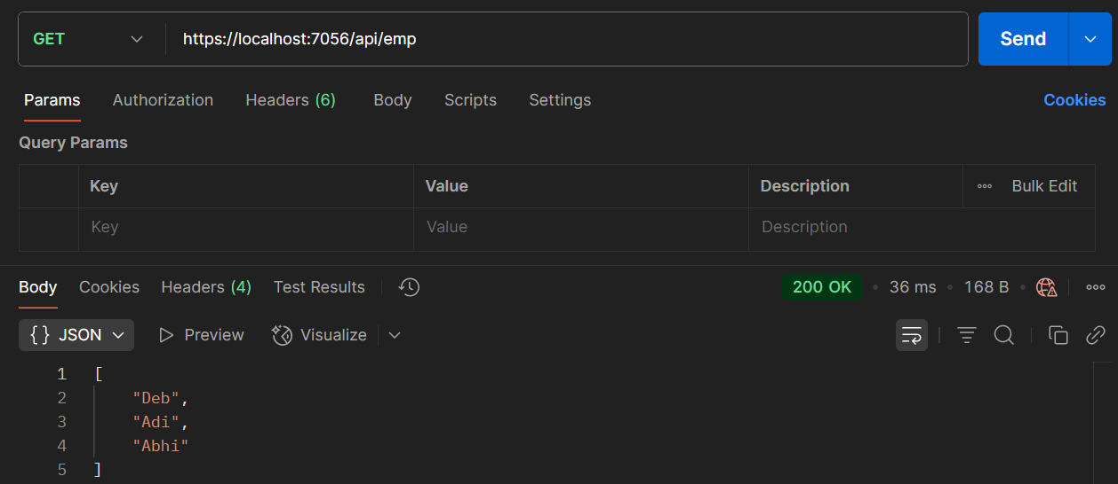
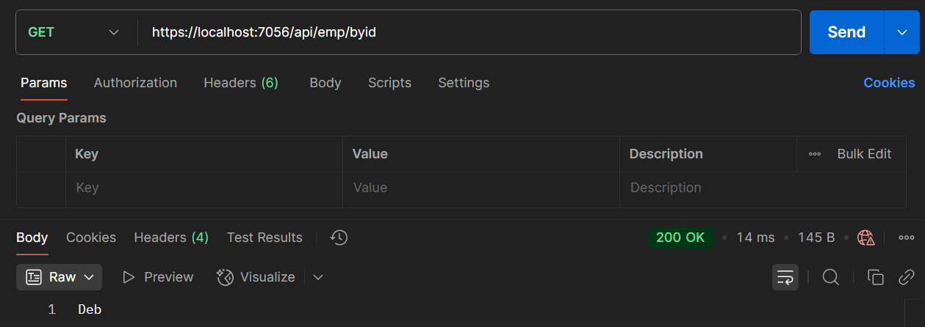

3: Web API using Custom Model, Auth filter and Exception Filter
Code –
Filename – Employee.cs
using System;
using System.Collections.Generic;
namespace MyFirstWebApi.Models
{
public class Employee
{
public int Id { get; set; }
public required string Name { get; set; }
public int Salary { get; set; }
public bool Permanent { get; set; }
public required Department Department { get; set; }
public required List<Skill> Skills { get; set; }
public DateTime DateOfBirth { get; set; }
}
}

Filename – Department.cs
namespace MyFirstWebApi.Models
{
public class Department
{
public int Id { get; set; }
public required string Name { get; set; }
}
}

Filename – Skills.cs
namespace MyFirstWebApi.Models
{
public class Skill
{
public int Id { get; set; }
public required string Name { get; set; }
}
}

Under Filter:
Filename – CustomAuthFilter.cs
using Microsoft.AspNetCore.Mvc;
using Microsoft.AspNetCore.Mvc.Filters;

namespace MyFirstWebApi.Filters
{
public class CustomAuthFilter : ActionFilterAttribute
{
public override void OnActionExecuting(ActionExecutingContext context)
{
var hasAuthHeader = context.HttpContext.Request.Headers.TryGetValue("Authorization", out var token);
if (!hasAuthHeader)
{
context.Result = new BadRequestObjectResult("Invalid request - No Auth token");
return;
}

if (!token.ToString().Contains("Bearer"))
{
context.Result = new BadRequestObjectResult("Invalid request - Token present but Bearer unavailable");
}
}
}
}

Filename – CustomExceptionFilter.cs
using Microsoft.AspNetCore.Mvc;
using Microsoft.AspNetCore.Mvc.Filters;
using System;
using System.IO;

namespace MyFirstWebApi.Filters
{
public class CustomExceptionFilter : IExceptionFilter
{
public void OnException(ExceptionContext context)
{
string message = $"Exception: {context.Exception.Message}";

var logPath = Path.Combine(AppDomain.CurrentDomain.BaseDirectory, "error_log.txt");
File.AppendAllText(logPath, message + Environment.NewLine);

context.Result = new ObjectResult("An unexpected error occurred")
{
StatusCode = 500
};
}
}
}

Output –
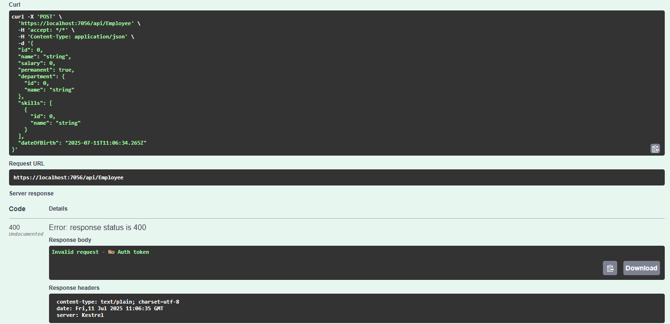
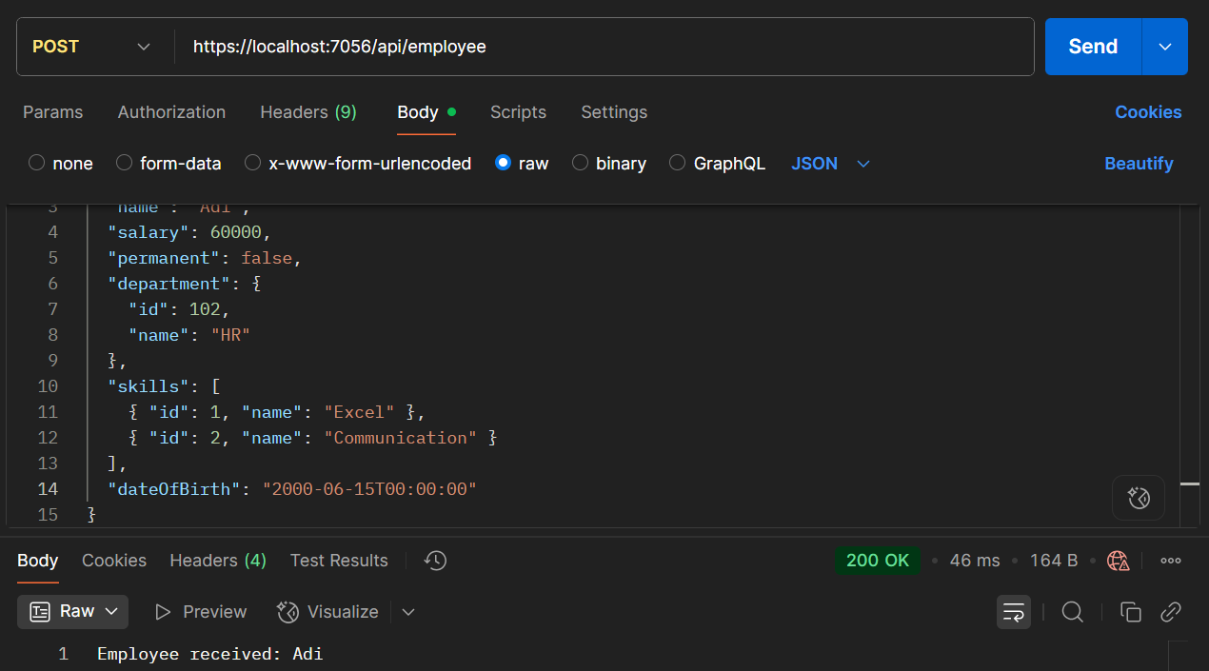
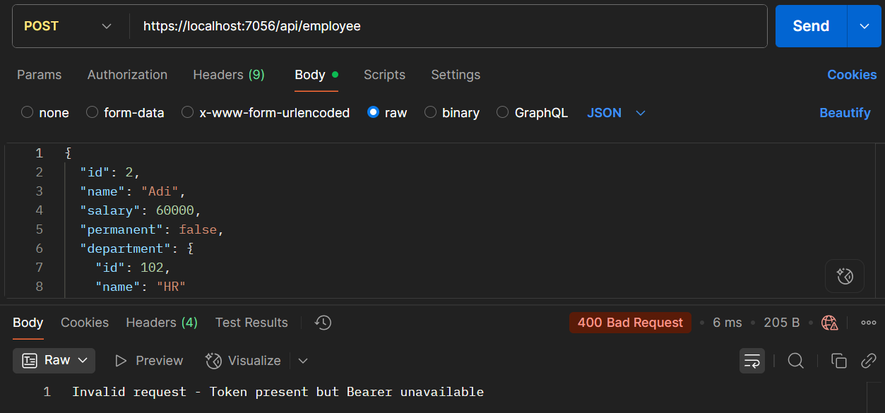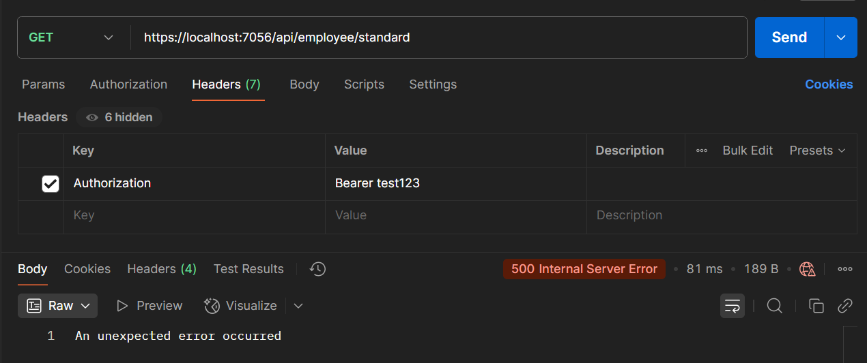

4: Web API CRUD Operation
Code –
Filename – EmployeeController.cs
using MyFirstWebApi.Filters;
using MyFirstWebApi.Models;
using Microsoft.AspNetCore.Authorization;
using Microsoft.AspNetCore.Mvc;

namespace MyFirstWebApi.Controllers
{
[ApiController]
[Route("api/[controller]")]
[AllowAnonymous]
[ServiceFilter(typeof(CustomAuthFilter))]
public class EmployeeController : ControllerBase
{
private List<Employee> employeeList;

public EmployeeController()
{
employeeList = new List<Employee>
{
new Employee
{
Id = 1,
Name = "Deb",
Salary = 60000,
Permanent = true,
Department = new Department { Id = 1, Name = "IT" },
Skills = new List<Skill>
{
new Skill { Id = 1, Name = "C#" },
new Skill { Id = 2, Name = "ASP.NET Core" }
},
DateOfBirth = new DateTime(2002, 10, 17)
},
new Employee
{
Id = 2,
Name = "Adi",
Salary = 50000,
Permanent = false,
Department = new Department { Id = 2, Name = "HR" },
Skills = new List<Skill>
{
new Skill { Id = 3, Name = "Excel" },
new Skill { Id = 4, Name = "Communication" }
},
DateOfBirth = new DateTime(2001, 8, 5)
}
};
}
[HttpGet("standard")]
[ProducesResponseType(StatusCodes.Status200OK)]
[ProducesResponseType(StatusCodes.Status500InternalServerError)]
public ActionResult<List<Employee>> GetStandard()
{
// throw new Exception("Forced exception for testing");
return Ok(employeeList);
}

[HttpPost]
public IActionResult Post([FromBody] Employee emp)
{
return Ok($"Employee received: {emp.Name}");
}

[HttpPut("{id}")]
public ActionResult<Employee> Put(int id, [FromBody] Employee updatedEmp)
{
if (id <= 0)
{
return BadRequest("Invalid employee id");
}

var employee = employeeList.FirstOrDefault(e => e.Id == id);

if (employee == null)
{
return BadRequest("Invalid employee id");
}
employee.Name = updatedEmp.Name;
employee.Salary = updatedEmp.Salary;
employee.Permanent = updatedEmp.Permanent;
employee.Department = updatedEmp.Department;
employee.Skills = updatedEmp.Skills;
employee.DateOfBirth = updatedEmp.DateOfBirth;

return Ok(employee);
}
}
}

Output –
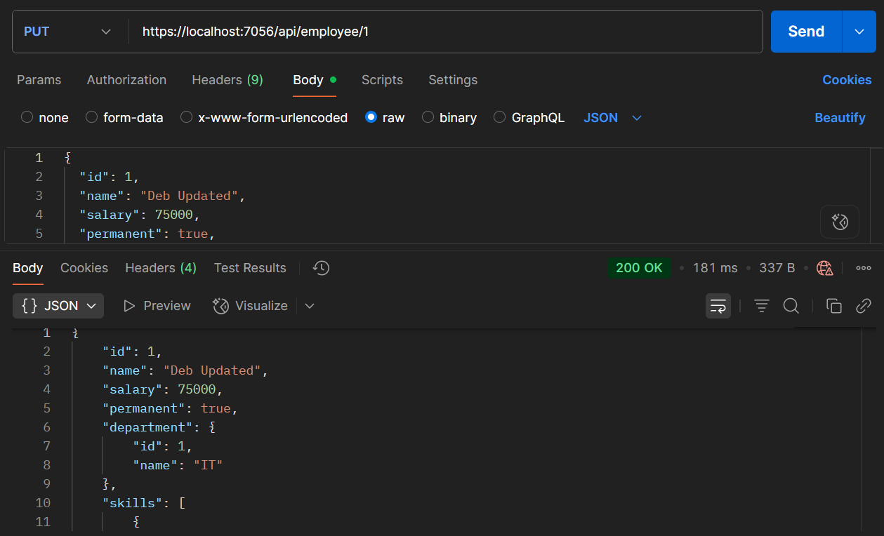
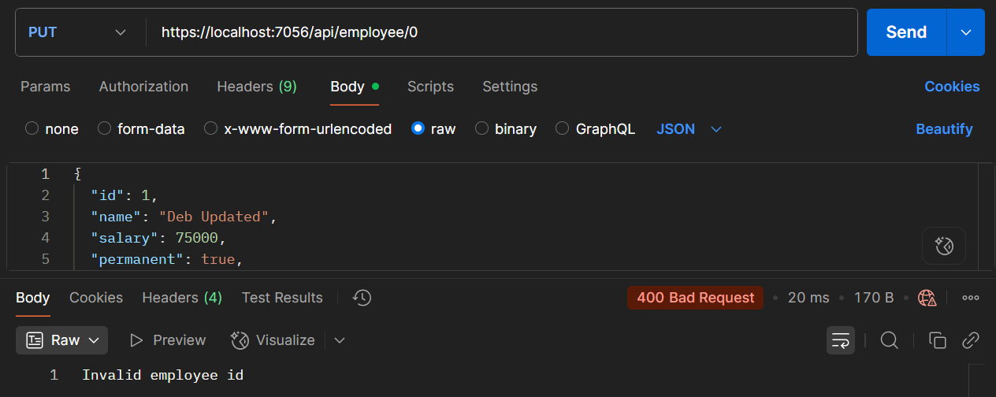
5: JWT Authentication in .NET Core Web API
Code –
Filename – Program.cs
using Microsoft.AspNetCore.Authentication.JwtBearer;
using Microsoft.IdentityModel.Tokens;
using Microsoft.OpenApi.Models;
using MyFirstWebApi.Filters;
using System.Text;
using System.IdentityModel.Tokens.Jwt;

var builder = WebApplication.CreateBuilder(args);
string securityKey = "mysuperdupersecrettokenkey1234567890";
var symmetricKey = new SymmetricSecurityKey(Encoding.UTF8.GetBytes(securityKey));

builder.Services.AddAuthentication(options =>
{
options.DefaultAuthenticateScheme = JwtBearerDefaults.AuthenticationScheme;
options.DefaultChallengeScheme = JwtBearerDefaults.AuthenticationScheme;
})
.AddJwtBearer(options =>
{
options.TokenValidationParameters = new TokenValidationParameters
{
ValidateIssuer = true,
ValidateAudience = true,
ValidateLifetime = true,
ValidateIssuerSigningKey = true,
ValidIssuer = "mySystem",
ValidAudience = "myUsers",
IssuerSigningKey = symmetricKey,
};

options.Events = new JwtBearerEvents
{
OnAuthenticationFailed = context =>
{
context.Response.StatusCode = 401;
context.Response.ContentType = "application/json";

if (context.Exception.GetType() == typeof(SecurityTokenExpiredException))
{
return context.Response.WriteAsync("{\"error\": \"Token expired\"}");
}

return context.Response.WriteAsync("{\"error\": \"Authentication failed\"}");
}
};
});

builder.Services.AddScoped<CustomAuthFilter>();
builder.Services.AddControllers(options =>
{
options.Filters.Add<CustomExceptionFilter>();
});

builder.Services.AddEndpointsApiExplorer();
builder.Services.AddSwaggerGen(c =>
{
c.SwaggerDoc("v1", new OpenApiInfo
{
Title = "Swagger Demo",
Version = "v1",
Description = "TBD",
TermsOfService = new Uri("https://example.com/terms"),
Contact = new OpenApiContact
{
Name = "Debanjan",
Email = "Deb@xyzmail.com",
Url = new Uri("https://www.example.com")
},
License = new OpenApiLicense
{
Name = "License Terms",
Url = new Uri("https://www.example.com")
}
});

c.AddSecurityDefinition("Bearer", new OpenApiSecurityScheme
{
Name = "Authorization",
Type = SecuritySchemeType.ApiKey,
Scheme = "Bearer",
BearerFormat = "JWT",
In = ParameterLocation.Header,
Description = "Enter 'Bearer {your-token}'"
});

c.AddSecurityRequirement(new OpenApiSecurityRequirement
{
{
new OpenApiSecurityScheme
{
Reference = new OpenApiReference
{
Type = ReferenceType.SecurityScheme,
Id = "Bearer"
}
},
Array.Empty<string>()
}
});
});

var app = builder.Build();

app.UseSwagger();
app.UseSwaggerUI(c =>
{
c.SwaggerEndpoint("/swagger/v1/swagger.json", "Swagger Demo");
});

app.UseHttpsRedirection();
app.UseAuthentication();
app.UseAuthorization();
app.MapControllers();
app.Run();

Filename – AuthController.cs
using Microsoft.AspNetCore.Authorization;
using Microsoft.AspNetCore.Mvc;
using Microsoft.IdentityModel.Tokens;
using System.IdentityModel.Tokens.Jwt;
using System.Security.Claims;
using System.Text;

namespace MyFirstWebApi.Controllers
{
[ApiController]
[Route("api/[controller]")]
[AllowAnonymous]
public class AuthController : ControllerBase
{
[HttpGet("token")]
public IActionResult GetToken()
{
try
{
var token = GenerateJSONWebToken(101, "Admin");
return Ok(new { token });
}
catch (Exception ex)
{
return StatusCode(500, $"Token generation failed: {ex.Message}");
}
}

private string GenerateJSONWebToken(int userId, string userRole)
{
var securityKey = new SymmetricSecurityKey(Encoding.UTF8.GetBytes("mysuperdupersecrettokenkey1234567890"));
var credentials = new SigningCredentials(securityKey, SecurityAlgorithms.HmacSha256);

var claims = new List<Claim>
{
new Claim(ClaimTypes.Role, userRole),
new Claim("UserId", userId.ToString())
};

var token = new JwtSecurityToken(
issuer: "mySystem",
audience: "myUsers",
claims: claims,
expires: DateTime.Now.AddMinutes(2),
signingCredentials: credentials);

return new JwtSecurityTokenHandler().WriteToken(token);
}
}
}

Filename – EmployeeController.cs
using MyFirstWebApi.Filters;
using MyFirstWebApi.Models;
using Microsoft.AspNetCore.Authorization;
using Microsoft.AspNetCore.Mvc;

namespace MyFirstWebApi.Controllers
{
[ApiController]
[Route("api/[controller]")]
[Authorize(Roles = "Admin,POC")]
public class EmployeeController : ControllerBase
{
private List<Employee> employeeList;

public EmployeeController()
{
employeeList = new List<Employee>
{
new Employee
{
Id = 1,
Name = "Deb",
Salary = 60000,
Permanent = true,
Department = new Department { Id = 1, Name = "IT" },
Skills = new List<Skill>
{
new Skill { Id = 1, Name = "C#" },
new Skill { Id = 2, Name = "ASP.NET Core" }
},
DateOfBirth = new DateTime(2002, 10, 17)
},
new Employee
{
Id = 2,
Name = "Adi",
Salary = 50000,
Permanent = false,
Department = new Department { Id = 2, Name = "HR" },
Skills = new List<Skill>
{
new Skill { Id = 3, Name = "Excel" },
new Skill { Id = 4, Name = "Communication" }
},
DateOfBirth = new DateTime(2001, 8, 5)
}
};
}
[HttpGet("standard")]
public ActionResult<List<Employee>> GetStandard()
{
return Ok(employeeList);
}

[HttpPost]
public IActionResult Post([FromBody] Employee emp)
{
return Ok($"Employee received: {emp.Name}");
}

[HttpPut("{id}")]
public ActionResult<Employee> Put(int id, [FromBody] Employee updatedEmp)
{
if (id <= 0)
return BadRequest("Invalid employee id");

var employee = employeeList.FirstOrDefault(e => e.Id == id);

if (employee == null)
return BadRequest("Invalid employee id");

employee.Name = updatedEmp.Name;
employee.Salary = updatedEmp.Salary;
employee.Permanent = updatedEmp.Permanent;
employee.Department = updatedEmp.Department;
employee.Skills = updatedEmp.Skills;
employee.DateOfBirth = updatedEmp.DateOfBirth;

return Ok(employee);
}
}
}

Output –
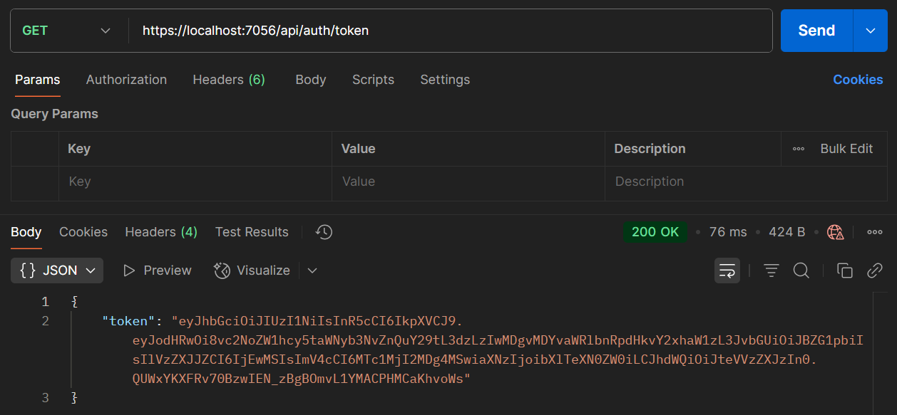
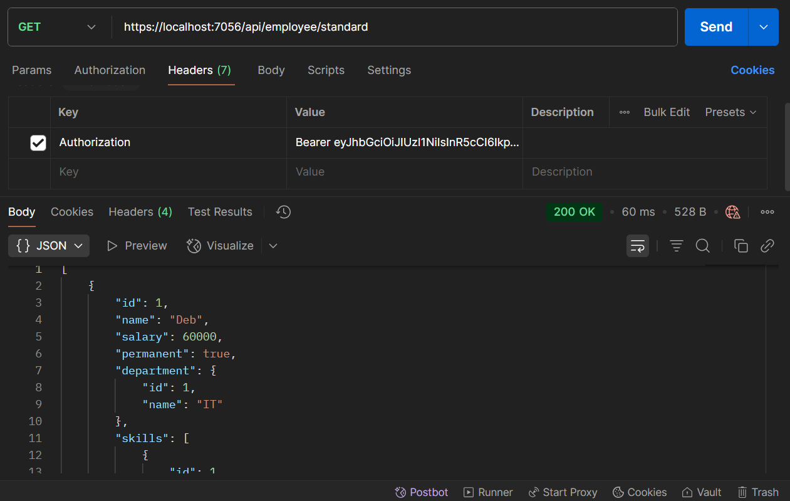
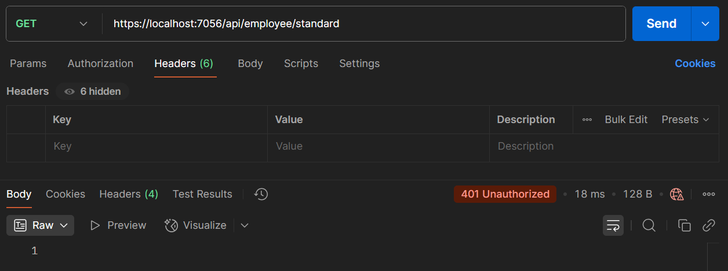
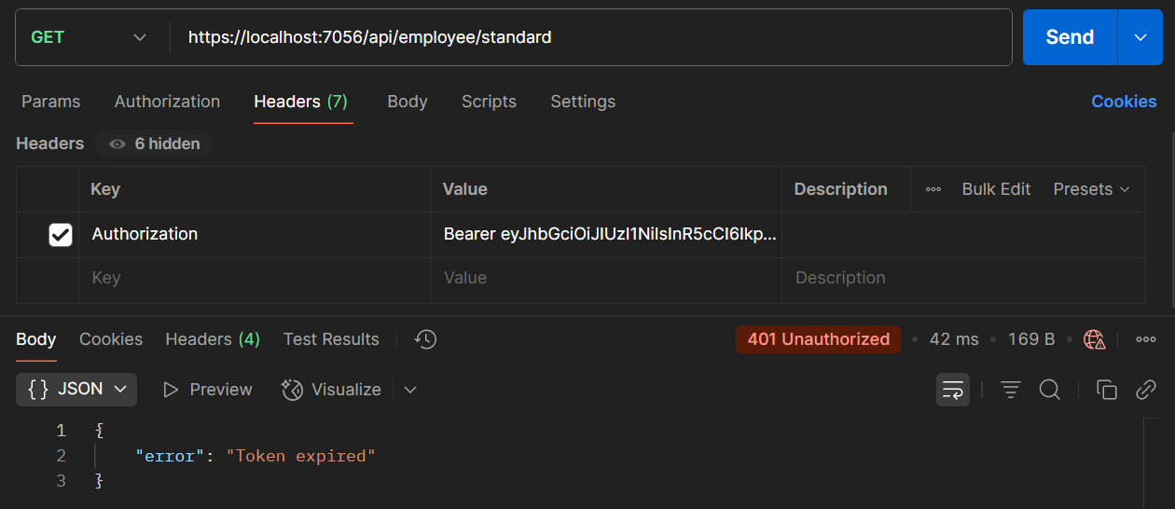

Name – Debasish Bisoi
Roll Number – 22052456
Superset ID - 6363141
College – Kalinga Institute of Industrial Technology (KIIT), Bhubaneswar

